1. (25p) Answer all the questions in an electronic document. By using the Matlab routine developed in 5.3 of session 5 (RCS): For the following scatter distribution. Calculate the RCS probability density function as in 5.5 and 5.6 of Lab session 5. Assume an operating Radar at 3 GHz at 1 Km from the target. By following Swerling type targets, how would you classify the one corresponding to the figure below and why.

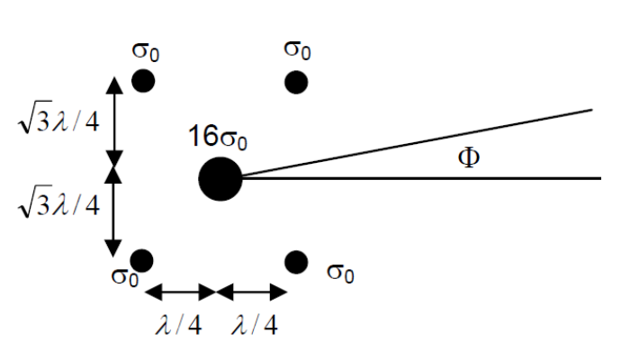

**Swerling model Statistics**

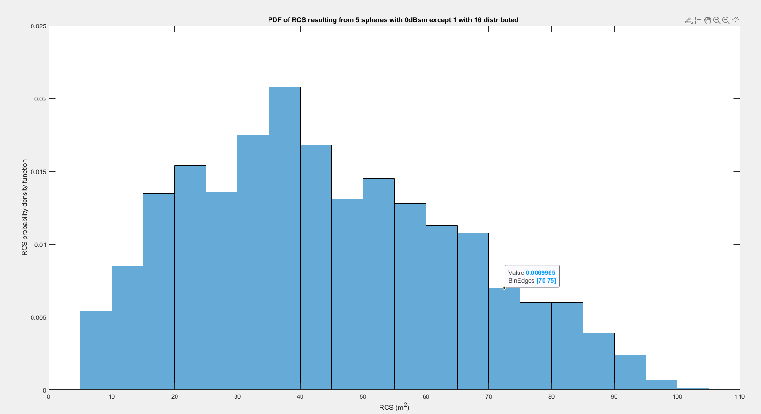

PDF of RCS resulting from %g spheres with 0dBsm except 1 with 16 distributed

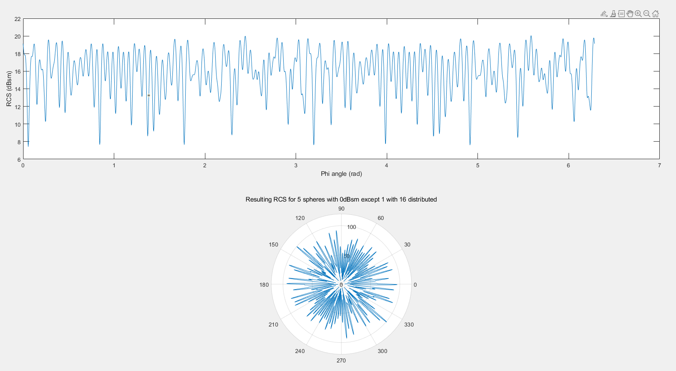

Resulting RCS for %g spheres with 0dBsm except 1 with 16 distributed

We will classify as swerling III/IV due to high fluctuations and also the DOF is equal to 4, as we can see from PDF.

